[×](javascript:void(0))

Kuncen WB1, Wirobrajan 10010, DIY

(+68) 120034509

info@yourdomain.com

[×](javascript:void(0))

Top of Form



Bottom of Form

* [Home (current)](NULL)
* About
* Special Dishes

Beef Steak Sauce Salmon Zucchini

* Menu
* Team
* Reservation

**We Love   
Delicious Foods!**

* **Fast Delivery**
* **Fresh Food**
* **24/7 Support**

About

**Welcome**

On her way she met a copy. The copy warned the Little Blind Text, that where it came from it would have been rewritten a thousand times and everything that was left from its origin would be the word "and" and the Little Blind Text should turn around and return to its own, safe country. A small river named Duden flows by their place and supplies it with the necessary regelialia. It is a paradisematic country, in which roasted parts of sentences fly into your mouth.

**Special Recipe**

[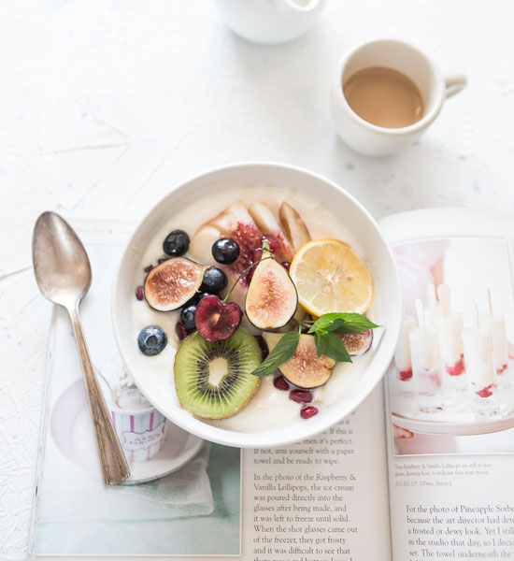](file:///C:\Users\Seyyed%20Javad%20Razavi\Desktop\web\11\resto\index.html)

**Australian Organic Beef**

[](file:///C:\Users\Seyyed%20Javad%20Razavi\Desktop\web\11\resto\index.html)

**Australian Organic Beef**

[](file:///C:\Users\Seyyed%20Javad%20Razavi\Desktop\web\11\resto\index.html)

**Australian Organic Beef**

Specialties

**Special Dishes**

**01.**

**Beef  
Steak Sauce**

Lorem ipsum dolor sit amet, consectetur adipisicing elit. Cupiditate, ea vero alias perferendis quas animi doloribus voluptates. Atque explicabo ea nesciunt provident libero qui eum, corporis esse quos excepturi soluta?

**$15.00**

book a table

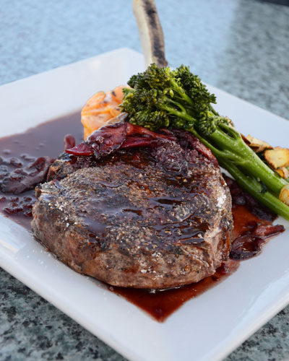

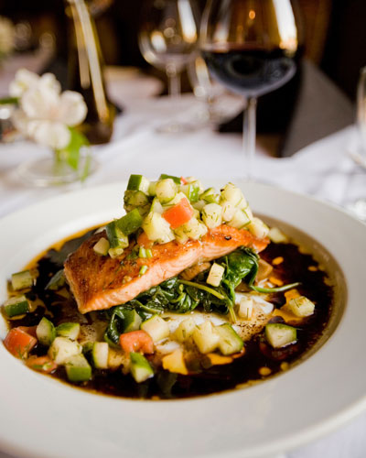

**02.**

**Salmon  
Zucchini**

Lorem ipsum dolor sit amet, consectetur adipisicing elit. Blanditiis, accusamus culpa quam amet ipsam odit ea doloremque accusantium quo, itaque possimus eius. In a quis quibusdam omnis atque vero dolores!

**$12.00**

book a table

Specialties

**Our Menu**

**Breakfast**

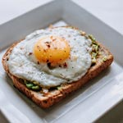

**Egg Sandwich**

**$30**

Meat Ball, Mie



**Egg Sandwich**

**$30**

Meat Ball, Mie



**Egg Sandwich**

**$30**

Meat Ball, Mie

**Breakfast**



**Egg Sandwich**

**$30**

Meat Ball, Mie



**Egg Sandwich**

**$30**

Meat Ball, Mie



**Egg Sandwich**

**$30**

Meat Ball, Mie

**Breakfast**



**Egg Sandwich**

**$30**

Meat Ball, Mie



**Egg Sandwich**

**$30**

Meat Ball, Mie



**Egg Sandwich**

**$30**

Meat Ball, Mie

Testimony

**Happy Customer**

Specialties

**Our Team**

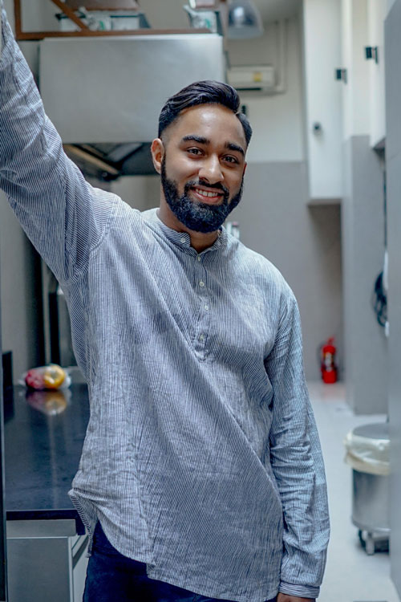

**Aaron Patel**

CEO

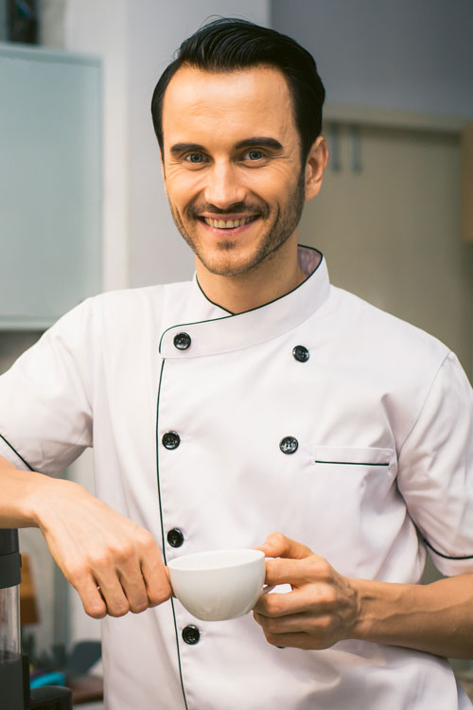

**Daniel Tebas**

Chef

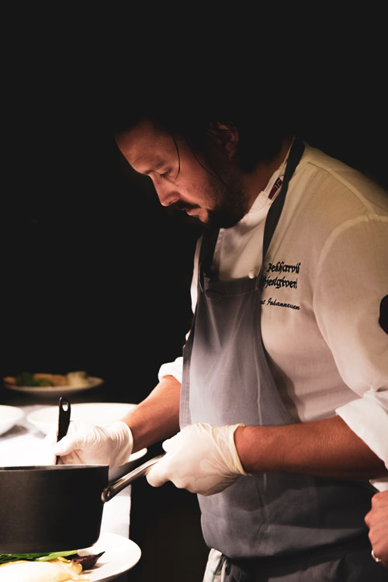

**Jon Snow**

Chef

Reservation

**Book Now**

Top of Form









Bottom of Form





Lorem ipsum dolor sit amet, consectetur adipisicing elit. Et obcaecati quisquam id sit omnis explicabo voluptate aut placeat, soluta, nisi ea magni facere, itaque incidunt modi? Magni, et voluptatum dolorem.

**Open Hours**

* Monday9:00 - 24:00
* Tuesday9:00 - 24:00
* Wednesday9:00 - 24:00
* Thursday9:00 - 24:00
* Friday9:00 - 02:00
* Saturday9:00 - 02:00
* Sunday Closed

**Newsletter**

Lorem ipsum dolor sit amet, consectetur adipisicing elit.

Top of Form

Bottom of Form